Osamu Shimomura
Osamu Shimomura was the first person to isolate GFP and to find out which part of GFP was responsible for its fluorescence. His meticulous research laid the solid foundations on which the GFP revolution was built. In 1960, shortly after he arrived in Princeton from Japan, Shimomura started studying the bioluminescence of the crystal jellyfish, Aequorea victoria.
Osamu Shimomura in the lab in the basement of his home. He is holding a sample of real GFP isolated from Aequorea victoria, not produced by bacteria. (Photo courtesy of Osamu Shimomura)
This jellyfish produces green bioluminescence from small photoorgans located on its umbrella (see Figures below). When the rings of twenty to thirty jellyfish are squeezed through a rayon gauze, a faintly luminescent liquid called squeezate is obtained. Shimomura went to Friday Harbor, Washington, to collect this squeezate and to extract from it the substance responsible for its luminescence. In order to do his research Shimomura estimates that he collected over a million Aequorea specimens, cut off the rings, and produced squeezate.
Right: Photoreceptors on umbrella of Aequorea victoria bioluminescing. (Photo courtesy of Osamu Shimomura)
He found that in order to bioluminesce Aequorea releases calcium ions. These bind to a protein that he called aequorin, which release blue light upon calcium binding. The blue light is absorbed by green fluorescent protein, which in turn gives off the green light as shown below.
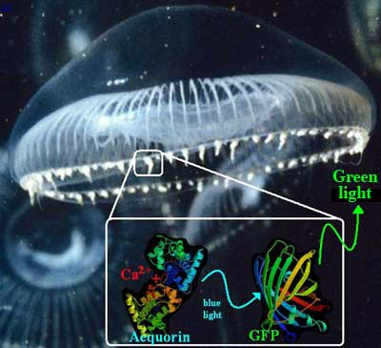
(Photo courtesy of Osamu Shimomura)
Osamu Shimomura's interest in Aequorea has always been based on its bioluminescence. He wanted to understand the chemistry and biochemistry involved in the production of its green glow and has never been interested in applications of GFP as a tracer molecule.

