Roger Tsien
Bacterial colony using various GFP and GFP-like proteins (from Tsien lab website).
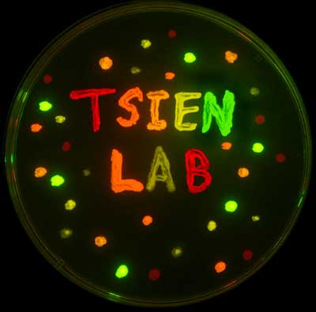
While Shimomura, Prasher and Chalfie were all instrumental in taking GFP from the jellyfish and showing that it can be used as a tracer molecule, it is Roger Tsien who is responsible for much of our understanding of how GFP works and for developing new techniques and mutants of GFP. His group has developed mutants that start fluorescing faster than wild type GFP, that are brighter and have different colors (see below, the E stands for enhanced versions of GFP, m are monomeric proteins and tdTomato is a head-to-tail dimer).
